**STREAMLINED ART INITIATION (START)**

**Training Manual 2016**

**INTRODUCTION**

**The Manual**

The manual will be used to train health workers both at the health facility and community on delivery of the START model. The START model delivery of ART care was designed to streamline ART initiation and to reduce access barriers to initiating ART. It will act as a guide and reference to facilitators when giving briefing to different cadres on the START model of care.

**Course aim**

The three-day course is designed to equip health workers and staff involved in the START model intervention with knowledge and skills so that they are able to run the START model in their various catchment areas.

**Course Objectives**

By the end of the session participants should have knowledge about:

1. START Model of Care
2. START Model Flow and Roles/Responsibilities
3. START Data Collection Forms
4. Counseling

Each topic has been explained and step by step activities have been included for easy follow up of the content. However, not every issue has been settled in regards to START. New scientific findings will need to be studied, interpreted, and discussed. The tools and information about START may evolve over time. This process will allow us to continue improving the START model of ART Initiation.

### **ABBREVIATIONS AND ACRONYMS**

SOP *Standard Operating Procedure*

HCW *Health Care Worker*

CLO *Community Liaison Officer*

LTFU *Lost to Follow Up*

**MODULE 1: OVERVIEW OF START MODEL**

**Time Allocation**: 1 hour 20 minutes

**Purpose:**

This session introduces and enables those involved in the START model intervention to acquire knowledge of START and how it will be implemented. This session provides those involved in the START model intervention with information regarding START and how it will be implemented.

**Learning objectives:**

By the end of this session, participants should be able to:

* Define START
* Identify the patient criteria to join START
* List the benefits of the START model of care

**Suggested Teaching/Learning Methods:**

Interactive games, lecture, discussion, brainstorming

**Suggested Teaching/ Learning Materials:**

Chalk and chalkboard, flip chart papers, permanent markers, transparencies and overhead projectors, audio-visual aids

Teaching and Learning Activities

**ACTIVITY 1: Overview of START (1 hour)**

The facilitator should facilitate the discussion on the definition of START, benefits, and criteria to join the model.

**What is START?**

START stands for Streamlined ART Initiation. The START model aims to deliver a higher intensity of treatment services by offering same-day CD4 testing and results, streamlined adherence counseling, and quicker initiation of life-long ART to patients enrolling in HIV care and treatment services.

The START program is designed to help HIV positive patients start taking antiretroviral therapy (ART) drugs as soon as possible. Pre-ART patients undergo same-day, point-of-care CD4 testing to help the clinician more quickly identify whether they meet criteria for ART initiation. Patients are then assessed by the clinician and prescribed ART if they are eligible. They undergo enhanced same-day adherence counseling throughout their clinical visit- with the clinician, adherence counselor, and pharmacist. Pre-ART counseling, which is usually spaced out over several visits, is completed on the same day to allow for quicker initiation of ART. Patients then continue with clinical care as usual.

**Criteria to join START**

The following criteria must be met for an individual to be eligible to join START:

***Inclusion criteria:***

* Not acutely ill
* ART naïve
* Meets Zambian HIV Guidelines for treatment initiation:
  + All confirmed HIV-infected children and adolescents <15 years old regardless of

CD4 count and/or World Health Organization Clinical Stage (WCS)

* + Adolescents ≥15 years old and adults with CD4 count ≤500 cells/mm3 regardless of WCS
  + Starting lifelong triple combination ART (cART) regardless of CD4 count and WCS:
* Pregnant & breastfeeding women
* HIV-infected sexual partners of pregnant & breastfeeding women
* HIV-infected partners in serodiscordant couples
* Patients with active tuberculosis (TB) disease
* Patients with hepatitis B virus (HBV) co-infection with severe liver disease

***Exclusion criteria:***

* Unable to provide consent/unwilling to enrol in START

**Goal of START**

The objective of the START model of care is to enable more rapid initiation of ART to decrease the number of patients lost before treatment begins. Zambian national care and treatment guidelines currently recommend three structured treatment preparation sessions prior to the initiation of ART for HIV positive non-pregnant adults, adolescents and children. This process can take between 2-4 weeks to complete after determination of ART eligibility. The START model aims to deliver a higher intensity of treatment services by offering same-day CD4 testing and results, streamlined adherence counseling, and quicker initiation of life-long ART to patients enrolling in HIV care and treatment services.

**Benefits of START**

***Benefits to START members***

* Fewer clinic visits to initiate ART, thus reducing transport costs and multiple days of long wait times for the patient
* Fewer days of lost work due to clinic visits prior to ART initiation
* Reducing the risk that patients will drop out from HIV care services by linking them directly to ART treatment more quickly.

***Benefits to the staff at the health facilities***

* Providing patients access to focused adherence counseling and ART on the same day they are determined to be eligible for treatment reduces the number of clinic visits and thereby the related congestion experienced by facilities
* Decongesting the clinics will potentially allow other patients to access quality service and allow providers to focus on patients with complicated or advanced disease

**EXERCISE 1: QUIZ 1 (20 minutes)**

The facilitator will ask the following questions and then will review the answers.

1. What does START stand for?
2. What is the primary objective of START?
3. What are the Zambian HIV requirements for ART initiation?
4. What are some benefits to patients of the START model?

**MODULE 2: START MODEL FLOW and ROLES AND RESPONSIBILITIES**

**Time Allocation:** 3 hours

**Purpose:**

This session will provide participants with information regarding the overall flow of the START model, including enrolment procedures.

**Learning Objectives:**

By the end of this session, participants should be able to:

* Describe the basic flow of the START model, including enrolment procedures
* State the roles and responsibilities of the different cadre in the START model

**Suggested teaching/learning methods:**

Lecture, discussion, brainstorming, demonstration, role play

**Suggested teaching and learning materials:**

Chalk and chalkboard, flip chart papers, permanent markers, transparencies, overhead projector, and audio-visual aids.

**______________________________________________________________________________**

**Teaching and Learning Activities**

**ACTIVITY 1: Review of START Flow Chart (15 minutes)**

The facilitator should distribute and review the START flow chart paying attention to which health care worker is performing each task. Participants should be given the opportunity to ask any questions that they might have at this stage.

**ACTIVITY 2: Review of START Roles and Responsibilities SOP and the Participant Recruitment and Enrolment Procedures SOP (1.5 hours)**

The facilitator should then carefully go through the entire *SOP Roles and Responsibilities*. The first step is to summarize the roles of each cadre of health worker. They should then proceed through the SOP and cover each of the key steps. While doing so, the facilitator should highlight that patients will receive adherence counseling at three steps: the ART provider, the adherence counselor, and the pharmacist. The facilitator should next review the *SOP Participant Recruitment and Enrolment*.

**EXERCISE 1: QUIZ #2 (15 minutes)**

The facilitator will ask the following questions and then will review the answers.

1. Who is responsible for conducting POC CD4 testing?
2. Who decides if someone is eligible for START?
3. At which point in the process does the patient receive adherence counseling?
4. Who completes the Time & Motion form?
5. Who decides when ART is started?

**EXERCISE 2: Role Play (1 hour)**

The facilitator will hand out “roles” on pieces of paper so that the participants can practice a mock enrolment scenario to make sure that everyone understands how these procedures will be conducted. Roles will include: Research Nurse, lay HCW, ART provider, adherence counselor, pharmacist, and patient. The role play will first be done at the front of the room with everyone else observing. Then, the entire training group will break up into groups of six and practice the role play within the smaller group.

**MODULE 3: START DATA COLLECTION FORMS**

**Time Allocation: 2 hours**

**Purpose:**

This session reviews the different data collection forms being used in the START model.

**Learning objectives:**

By the end of this session, participants should be able to;

* Define the POC CD4 Log Book
* Define the START Enrolment Form
* Define the Time & Motion Form
* Define the ART Assessment Form
* Understand when, how, and who completes each of these forms

**Suggested teaching/learning methods:**

Lecture, discussion, brainstorming, exercise, question and answer

**Suggested teaching and learning materials:**

Chalk and chalkboard, flip chart papers, permanent markers, paper and pens, transparencies and overhead projectors, audio-visual aids.

______________________________________________________________________________

**Teaching and Learning Activities**

**ACTIVITY 1: Review of Forms (1 hour)**

The facilitator should distribute or refer the trainee to the appropriate forms in their training manual as they are reviewed.

**1. POC CD4 Log Book**

* This form will be used to document the POC CD4 test results.
* It will also be used to record the time it takes to conduct POC CD4 testing; the time when CD4 testing is started and when it is completed will also be recorded here.
* The nurse will be responsible for recording POC CD4 data in the log book.

**2. START Enrolment Form**

* This form collects important demographic details on the patient being enrolled in START
* The first page of this form should be filled out immediately after the patient agrees to initiate START
* The fourth page of the form (titled START only) should be filled out at the end of the day using the patient’s ARV file

**3. Time & Motion Form**

* This form provides insight on the duration of particular activities within the START model by having a timestamp on each activity (when did each activity begin and when was it completed). This type of form will provide understanding regarding the amount of time each activity takes
* The first part of the Time & Motion form will be completed by the Nurse. All subsequent steps will be completed by the lay HCW.

**5. ART Assessment Form**

* This form consolidates the three separate adherence counseling sessions provided by current national HIV guidelines into one form. The form covers *Enrolment Assessment*, *ART Eligibility*, *ART Initiation*, and *Patient Willingness*.
* This form will be completed by the adherence counselor

**EXERCISE 1: Practice Completing Each Form (1 hour)**

Blank copies of each form will be handed out and training participants will practice filling in each form. Nurses should focus particularly on the START Enrolment Form, the POC CD4 log book, and the Time & Motion form. The lay HCW should focus particularly on the Time & Motion form and the ART assessment form.

**MODULE 4: COUNSELING**

**Time Allocation: 2 hours**

**Purpose:**

This session will provide participants with information on how patients will be counseled once they are determined to be ART eligible.

**Learning objectives:**

By the end of this session, participants should be able to;

* Understand each section of the ART Assessment Form
* Understand potential patient responses to ART Assessment Form questions

**Suggested teaching/learning methods:**

Lecture, discussion, brainstorming, exercise, question and answer

**Suggested teaching and learning materials:**

Chalk and chalkboard, flip chart papers, permanent markers, paper and pens, transparencies and overhead projectors, audio-visual aids.

______________________________________________________________________________

**Teaching and Learning Activities**

**ACTIVITY 1: Review of Counseling provided to ART-naïve patient (1 hour)**

The facilitator will provide a detailed review of the *ART Assessment Form* which will be utilized during patient counseling.

This form is divided into four sections (A-D) and consolidates what would be included in three separate adherence counseling sessions into one accelerated session. It is critical that, when asking the questions on the form, the adherence counselor understands the potential anticipated responses from patients to correctly assess their knowledge and readiness to initiate ART.

The facilitator will review the form with participants, question by question, asking for volunteers to provide their own answers to the questions. Using the *Expected Answers to ART Assessment* document that provides support to the questions on this form, the facilitator will provide feedback to the participants.

It is important that participants understand that different adherence counseling will provided to patients. While the knowledge covered is the same, the form is organized differently.

**ACTIVITY 2: Role Play (1 hour)**

Using the knowledge acquired in the activity above, participants will divide into pairs and practice using the *ART Assessment Form* on one another. The facilitator will walk around the room to ensure that the form is being filled correctly and that corresponding answers to questions are accurate.

**APPENDICES**

1. START Infographic
2. SOP 2.15 Roles and Responsibilities of START Personnel
3. START Model Flowchart
4. SOP 2.4: START Participant Recruitment, Consent, Enrolment
5. POC CD4 Log Book
6. Comprehension Assessment Tool
7. START Enrollment Form - Intervention
8. Time & Motion Form
9. ART Assessment Form
10. START Assessment Form: Guide to Expected Respondent Answers
11. SOP 2.7: Dried Blood Spot (DBS) Collection and Handling
12. Viral Load Log Book
13. **START Infographic**

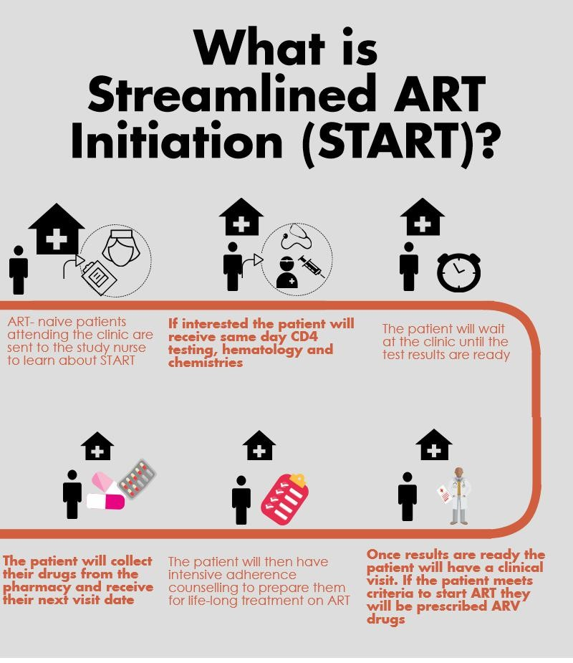

1. **SOP 2.15: Roles and Responsibilities of START Personnel**

### **PURPOSE**

This standard operating procedure (SOP) is to describe the key roles and responsibilities for all personnel specifically in relation to model 4: Streamlined ART initiation (START).

### **SCOPE**

This SOP applies to all personnel working at sites where START is an intervention.

**MATERIALS**

START Enrollment Form

START Time & Motion Form

START ART Assessment Form

START POC CD4 Log Book

PIMA machine and materials for POC CD4 testing

**RESPONSIBILITIES**

### All personnel involved in the START model are responsible for adhering to the START protocol understanding and following this SOP, and following guidelines for the ethical conduct of patient care at all times.

* **Nurse** is responsible for:
  + Describing START in detail to potential participants
  + Conducting venous blood draw for routine hematology/chemistry tests
  + Conducting same day CD4 testing and urinalysis and recording CD4 test results
  + Determining preliminary eligibility for ART initiation for purposes of START enrolment
  + Recruitment and enrolment of eligible patients
  + Initiating the Time & Motion form
  + Completion of the START Enrolment form
* **Lay Health Care Worker** is responsible for:
  + Identifying pre-ART patients who are due for CD4 count and potentially eligible for START participation
  + Facilitating smooth flow for the patient throughout the clinical visit
  + Completing the Time & Motion form
  + Transferring patient ARV files between the clinician, adherence counselor, pharmacist, nurse, and data associate for final entry care into SmartCare
* **Clinician** is responsible for
* Determining final eligibility for ART initiation
* Prescribing ARVs and other medicines as appropriate
* Providing pre-ART counseling
* Providing the next clinical appointment date
* **Adherence Counselor** is responsible for
  + Providing pre-ART counseling
  + Completing the ART assessment form
* **Pharmacy Technologist** is responsible for
  + Dispensing ARVs and other medicines
  + Entering data into the SmartCare pharmacy form
  + Providing the next pharmacy appointment date
* **Data Associate** is responsible for entering participant data into SmartCare
* **The QA/QC Coordinator i**s responsible for overseeing all quality control procedures related to this model

**PROCEDURES**

1. Patients will be identified by **the lay HCW** for enrollment into the START model from two points in the facility.
   1. First, from the enrollment room at the facility, where a patient with a referral slip (yellow slip) will be sent for their initial visit after learning of their HIV+ status.
   2. Second, from the registry where patients have already been enrolled as clients at the facility, however, due to their CD4 count have not yet been eligible for initiation of ART.
2. After potential candidates have been identified by the Lay HCW, they will be referred to the **Nurse** who will
   1. Introduce themselves to the participants and clearly explain the START model.
   2. Inquire whether the patient is interested in participating in START.
      1. For patients unwilling to participate in START, thank them for their time and refer them to proceed through the clinic as per regular standards.
      2. If the patient is interested, conduct (a) venous blood draw for renal, liver, and hematology tests according to national guidelines (routine Creatinine, ALT, AST and Hemoglobin) (b) Point-of-care (POC) CD4 test (c) POC urinalysis. The tests should be conducted in that order.
      3. Use the CD4 POC Log Book to document the time that testing for POC CD4 began.
      4. Ask the patient to wait at the facility for the results of the CD4 and urinalysis test.
      5. Enter the CD4 results in the Point of Care Log Book and place the paper result (from the PIMA machine) in the patient’s ART file. The time that the CD4 result was obtained should also be recorded.
      6. The urinalysis result should be documented according to current clinical standards
   3. Determine patient’s preliminary eligibility for ART initiation using National HIV Guidelines and communicate POC CD4 result to the patient.
   4. RN will complete Page 1 of the paper Enrollment form.
   5. Send patient with lay HCW for Clinician visit
3. The **Lay HCW** will
   1. Escort the patient to the Clinician and wait outside the office.
   2. Note the time that the interview with Clinician begins on the START Time & Motion form
4. The **Clinician** will
   1. Complete patient routine history and physical examination
   2. Review the CD4 results and urinalysis
   3. Determine patient WHO staging
   4. Determine patient’s final eligibility for ART initiation using Zambian National HIV Guidelines
   5. Manage any co-morbid conditions as needed
   6. Provide adherence counseling and treatment preparation
   7. Prescribe medicines and schedule the patient’s clinical next visit.
   8. Address any questions or concerns the patient may have.
5. The **lay HCW** will
   1. Note the time that the interview with Clinician ends on the START Time & Motion form
   2. Escort the patient to the adherence counselor and wait outside the office.
6. The **Adherence Counselor** will
   1. Conduct adherence counseling with the patient
   2. Complete the ART Assessment Form
   3. Answer any questions patient may have regarding their care and treatment.
7. The **lay HCW** will
   1. Escort the patient to the pharmacy to collect their drugs.
   2. The lay HCW will record the time the patient receives medications from the pharmacist using the Time & Motion form
8. The **Pharmacy Technologist** will
   1. Provide additional adherence counseling to the patient
   2. Answer any questions the patient may have.
   3. Provide the patient with any medications prescribed by the Clinician
   4. Document drug dispensation in SmartCare pharmacy form
9. The **lay HCW** will
   1. Collect the patient’s ARV file from the pharmacist and provide it to the nurse.
10. At the end of the day, the **nurse** will:
    1. Complete the Enrolment Form, page 4 (START only) using the patient’s ARV file
11. The **lay HCW** will take patient ARV files to the data associate for entry into SmartCare

### **ABBREVIATIONS AND ACRONYMS**

SOP *Standard Operating Procedure*

START *Streamlined ART Initiation*

HCW *Health Care Worker*

*RN Research Nurse*

*DBS Dried Blood Spot*

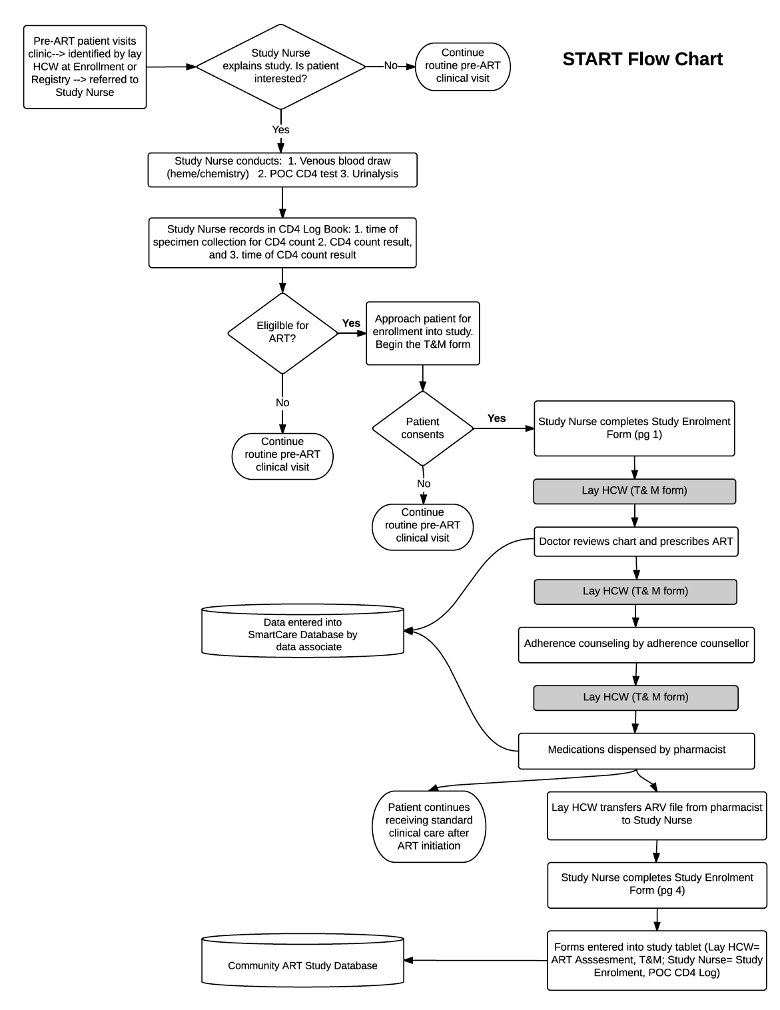**3.0 START MODEL FLOWCHART**

**4** **.0 SOP 2.4: START Participant Recruitment and Enrolment**

### **PURPOSE**

This standard operating procedure (SOP) describes the procedures to be followed when recruiting and enrolling patients for Streamlined ART initiation (START) model

### **SCOPE**

This SOP applies to all personnel involved in recruitment and enrolment of study participants.

**MATERIALS**

START Comprehension Assessment Tool

Enrollment Form

Point of Care CD4 Log Book

START Time & Motion Form

**RESPONSIBILITIES**

### All personnel involved in recruiting and enrolling patients for START model in the Community ART study are responsible for adhering to the SMART protocol, implementing appropriate procedures, understanding and following this SOP, and following guidelines for the ethical conduct of patient care at all times.

### **Lay Health Care Worker** is responsible for approaching potential participants for recruitment in the study

* **Nurse** is responsible for enrolling participants in compliance with the requirements of this SOP
* **QA/QC Coordinator i**s responsible for overseeing all quality control procedures

**PROCEDURES FOR RECRUITMENT**

* Patient will be identified by the **lay HCW** for recruitment into the START study model from two points in the facility.
  + **First,** from the enrollment room at the facility where a patient with a referral slip will be sent for their initial visit after learning of their HIV+ status.
  + **Second,** from the registry where patients have already been enrolled as clients at the facility, however, due to their CD4 count have not yet been

eligible for initiation of ART.

* The **Lay HCW** will:
  + Introduce themselves to the potential enrollee
  + Briefly explain the START model to the patient
  + Ask if patient is interested
  + If interested, escort the patient to the Nurse
  + If not interested thank the patient for their time.

* A**ssessing for ART Eligibility**

The **Nurse** will,

* + Introduce themselves and thank the patient for their time
  + Clearly explain the START model.
    - Conduct (a) venous blood draw for renal, liver, and hematology tests according to national guidelines (routine Creatinine, ALT, AST and Hemoglobin) (a) point-of-care (POC) CD4 testing (b) POC urinalysis. The tests should be conducted in that order.
    - Use the CD4 POC Log Book to document the time that testing for POC CD4 is begun.
    - Ask patient to wait at the facility for the CD4 and urinalysis results to be ready.
    - Enter the CD4 results in the Community ART Point of Care Log Book and place the paper result (from the PIMA machine) in the patient’s ART file. The time that the CD4 result was obtained should also be recorded.
    - The urinalysis result should be documented according to current clinical standards
    - Nurse will then assess for preliminary eligibility for ART initiation.

*Criteria for ART eligibility (Zambian National HIV Guidelines):*

* + - * All confirmed HIV-infected children and adolescents <15 years old regardless of CD4 count and/or World Health Organization Clinical Stage (WCS)
      * Adolescents ≥15 years old and adults with CD4 count ≤500 cells/mm3 regardless of WCS
      * Starting lifelong triple combination ART (cART) regardless of CD4 count and WCS:
        + Pregnant & breastfeeding women
        + HIV-infected sexual partners of pregnant & breastfeeding women
        + HIV-infected partners in serodiscordant couples
        + Patients with active tuberculosis (TB) disease
        + Patients with hepatitis B virus (HBV) co-infection with severe liver disease

If the patient does not meet criteria for ART initiation, they will be informed to continue with standard of care at the clinic (including returning to clinic in 6 months for repeat testing).

**PROCEDURES FOR ENROLLMENT**

* If eligible, the nurse will:
* Complete the Enrolment Form, page 1
* Refer the patient to the Clinician
* The lay HCW will escort the patient through the clinical visit as outlined in SOP *2.15 START Roles and Responsibilities.* When the patient is done with their clinical visit, the lay HCW will (a) enter the ART Assessment Form & the Time & Motion form into the database and (b) will retain the patient’s ARV file and provide the file to the nurse.
* At the end of the day, the nurse should:
* Complete the Enrolment Form, page 4 (START only) using the patient’s ARV file
* The lay HCW will then give the patient ARV files to the data associate for entry into SmartCare

### **ABBREVIATIONS AND ACRONYMS**

SOP *Standard Operating Procedure*

START *Streamlined ART Initiation*

HCW *Health Care Worker*

**5.0 POC CD4 Log Book**

**Clinic Name:** _______________________________________________________

|  |  |  |  |  |  |  |
| --- | --- | --- | --- | --- | --- | --- |
| **ART ID** | **Patient First Name** | **Patient Surname** | **Date**  **(DD/MM/YY)** | **Time**  **specimen collection**  **for POC CD4 started**  **(HH:MM)** | **POC CD4 test result** | **Time**  **POC CD4 test result recorded**  **(HH:MM)** |
|  |  |  |  |  |  |  |
|  |  |  |  |  |  |  |
|  |  |  |  |  |  |  |
|  |  |  |  |  |  |  |
|  |  |  |  |  |  |  |
|  |  |  |  |  |  |  |
|  |  |  |  |  |  |  |
|  |  |  |  |  |  |  |
|  |  |  |  |  |  |  |
|  |  |  |  |  |  |  |
|  |  |  |  |  |  |  |
|  |  |  |  |  |  |  |

**10.0 START Enrollment Form**

**Part 1: General**

|  |  |
| --- | --- |
| 1. | Which model is patient being enrolled into?  🞏 CAG  🞏 UAG  🞏 Fast-Track  🞏 START |
| 2. | Date of enrollment (DD/MM/YY): __ __/__ __/__ __ |
| 3. | Enrolled by: |
| 4. | Clinic Name: |
| 5. | Patient First Name: |
| 6. | Patient Surname: |
| 7. | ART ID: |
| 8. | Sex (M/F): |
| 9. | Date of Birth (DD/MM/YY): __ __/__ __/__ __ |
| 10. | Patient Mobile Number 1: |
| 11. | Patient Mobile Number 2: |

**Part 4: START Model**

|  |  |
| --- | --- |
|  | ***Please complete this section on the day of enrollment AFTER patient has left the clinic for the day. Use the clinic chart to complete these questions.*** |
| 1. | Date of HIV Diagnosis(DD/MM/YY): __ __/__ __/__ __ |
| 2. | Was patient already enrolled in pre-ART before today?  🞏 Yes Go to question 2a  🞏 No Skip to question 3 |
| 2a. If the answer to question 2 is yes, please indicate the date and value of the last CD4 count: |
| Date of last CD4 count (DD/MM/YY): __ __/__ __/__ __ |
| Last CD4 Count: _____________ |
| 3. | Current WHO STAGE (as listed on today’s clinical visit form):  🞏 I  🞏 II  🞏 III  🞏 IV |
| 4. | Does the patient currently have an acute opportunistic infection (based on review of today’s clinical visit form or discussion with the ART provider)?  🞏 Yes  🞏 No |
| 5. | Was ART dispensed today?  🞏 Yes  🞏 No |

**11.0 Time & Motion Form**

**START Time & Motion Form**

***Please enter information here when you perform tasks during the workday. Do not complete from memory at the end of the day.***

**Clinic Name: __________________________________**

**Patient First Name: _____________________________**

**Patient Surname: _______________________________**

**ART ID: ________________________________________**

|  |  |  |
| --- | --- | --- |
|  | **DATE**  **(DD/MM/YY)** | **TIME**  **(HH:MM)** |
| Clinician visit started  (**Completed by Lay HCW)** |  |  |
| Clinician visit ended  (**Completed by Lay HCW)** |  |  |
| Adherence Counseling started  **(Completed by Lay HCW)** |  |  |
| Adherence Counseling ended  **(Completed by Lay HCW)** |  |  |
| ART dispensed  **(Completed by Lay HCW)** |  |  |

|  |  |
| --- | --- |
| **12.0 ART Assessment Form** | |
|  | |
| Clinic Name: _______________________________________  ART ID: ___________________________________________  Patient First Name: __________________________________  Patient Surname: ___________________________________ | Date (DD/MM/YY):  |__|__|/|__|__|/|__|__| |
|  |

|  |  |  |  |  |  |
| --- | --- | --- | --- | --- | --- |
| *For all sections assess whether patient understands following points after interacting with counselor*  **Section A. Enrollment and Assessment** | | | | | |
| 1. What is HIV? | | | | | □ Yes □ No |
| 1. What is AIDS? | | | | | □ Yes □ No |
| 1. How is HIV spread? | | | | | □ Yes □ No |
| 1. How can HIV be prevented? | | | | | □ Yes □ No |
| 1. Why is it important to disclose HIV status? | | | | | □ Yes □ No |
| 1. What are CD4 cells? | | | | | □ Yes □ No |
| 1. What is viral load? | | | | | □ Yes □ No |
| 1. What are the benefits of starting ART? | | | | | □ Yes □ No |
|  | | | | |  |
| **Section B: cART Eligibility** | | | | | |
| 1. What is ARV? □ Yes □ No 2. Who should start ART? □ Yes □ No 3. What other considerations are there to understand before starting ART? □ Yes □ No 4. Is starting ART an emergency? □ Yes □ No 5. What are the benefits of starting ART? □ Yes □ No 6. What is resistance? □ Yes □ No 7. How does resistance occur? □ Yes □ No 8. How can resistance be prevented? □ Yes □ No 9. Why is it important to have perfect adherence? □ Yes □ No | | | | | |
|  |  |  |  |  | |

**Section C. cART Initiation**

1. Patient understands steps to developing a successful treatment plan? □ Yes □ No
2. Patient understands the importance of knowing their ART medication regimen? □ Yes □ No
3. Patient understands possible drug side effects? □ Yes □ No
4. Patient understands that taking ART is life-long and they should not stop without consulting a doctor? □ Yes □ No
5. Patient understands how resistance can be prevented □ Yes □ No

|  |  |  |  |  |
| --- | --- | --- | --- | --- |
| **Section D. Patient Willingness** | | | | |
| 1. Is the patient willing to start ART at the present time? | | | | |
| □ Yes🡪 | If yes, what reasons does the patient give for being willing to start ART? *(mark all that apply)* | Knowledge:   * I feel unwell and ART will make me healthy again * I feel well and ART will keep me healthy * It is important to start ART quickly when you are sick to get healthy again   Prioritization:   * ART will help me continue to work * ART will help me continue to take care of my family * ART will minimize risks of giving HIV to my children through childbirth * ART can help me avoid putting others at risk for HIV | Shared commitment/access:   * This clinic will take care of me and wants to help me * Coming to clinic is well worth my time and effort * I feel safer once I am on ART * My spouse/partner is on therapy   Other, specify: | |
| □ No🡪 | If no, what reasons does the patient give for being unwilling to initiate ART today? *(mark all that apply)* | Structural:   * Cannot return for follow-up because of transport costs * Cannot return for follow-up because work responsibilities * Cannot make a decision today because has to leave / left urgently for family/work   Health care delivery:   * Conflict with provider wants to seek care elsewhere * Unhappy with clinic and wants to seek care elsewhere   Psychosocial:   * Prefers spiritual or traditional treatment to ART * Too emotionally distressed to make decision or plan * Is intoxicated and unable to make a plan * Does not accept HIV diagnosis * Feels fine and does not want treatment * Does not want to take indefinite treatment | | * Fears potential side effects * Initiating treatment would lead to risk of disclosure and family or community rejection * Initiating treatment would lead to risk of disclosure and conflict with spouse / domestic violence * Initiating treatment would lead to risk of disclosure and loss of job or work   Other, please specify: |
| Comments: | | | | |

**13.0 START Assessment Form: Guide to Expected Respondent Answers**

**Section A: Enrollment Assessment**

1. What is HIV?

* + HIV is a virus that attacks the body
  + It damages your ability to fight germs and disease
  + The virus makes many copies of itself every day if you are not on treatment
  + Without treatment people progress from no symptoms to minor illness to severe life-threatening illness and death

2. What is AIDS?

* + AIDS occurs when the body is overcome by the HIV virus and becomes weak due to other illnesses
  + HIV causes AIDS months to years after infection

3. How is HIV spread?

* Unprotected sex is the most common method
* Sharing needles or blood contaminated sharp objects (razors, knives, etc.)
* Mother to child either before, during or after delivery (in the womb, during delivery, or while breastfeeding)
* Infected body fluids in contact with
  + - Soft moist skin in the mouth, nose, vagina or rectum
    - Cuts in the skin
* Traditional beliefs that facilitate HIV transmission (sexual cleansing, wet nursing, dry sex, pre-coital pubic shaving with shared razor, etc.)
* HIV is NOT spread through sharing food or utensils, touching, kissing, mosquitoes, or curses

4. How can HIV be prevented?

* Using condoms when engaging in sexual contact
* Abstaining from sex
* Knowledge of sexual partner’s HIV status
* Being faithful to your one partner/spouse
* Becoming circumcised if an HIV negative male (can reduce risk of transmission)
* Taking ARVs perfectly and using condoms when engaging in sexual contact

5. Why is it important to disclose HIV status?

* Sharing your test results with someone you trust who can support you is associated with better success in managing HIV
* Your family should become a source of support and help in your treatment of HIV
* Notifying your sexual partner so they can be tested also can help stop HIV spread

6. What are CD4 cells?

* The immune system works in your body to fight infections and keep you healthy
* CD4 cells are the “soldiers” of your immune system army
* CD4 cells recognize germs in your body, and they work with other cells to destroy them
* HIV attacks and destroys your CD4 cells
* When CD4 cells are destroyed by HIV, the immune system does not know how to fight germs

7. What is viral load?

* Viral load is the amount of HIV virus in the blood
* The lower the amount of HIV virus in the blood the better
* CD4 cells are the “soldiers” of your immune system army
* CD4 cells recognize germs in your body, and they work with other cells to destroy them
* HIV attacks and destroys your CD4 cells
* When CD4 cells are destroyed by HIV, the immune system does not know how to fight germs
* When the amount of HIV virus increases, eventually you don’t have enough CD4 cells to fight HIV and other germs that enter your body, and you progress to AIDS

8. What are the benefits of starting ART?

* Starting HIV treatment before you become sick and have AIDS will make it easier to lower the HIV virus in your blood and increase your CD4 cells faster
* It will also make the potential side effects from treatment easier to tolerate
* It will prevent you from developing more serious infections, and improve your chance of living a normal life with HIV

**Section B: ART Eligibility**

1. What is ARV?

* ARV stands for Anti-Retro Viral
* ARVs are medicines that help control the HIV virus in the blood
* ART is Anti-Retroviral Therapy, and refers to the combination of ARVs which are used to fight HIV

2. Who should start ART?

* You cannot always tell by looking at someone if they need ART
* Even if you look and feel healthy, your immune system may already be weakened (low CD4 cell count), and you may benefit from starting ART to prevent you from getting sick
* You should start ART if you are experiencing illnesses or your immune system is weakened (low CD4 cell count)
* An HIV+ person does not always need to start ART immediately, and some people may have no illnesses and a healthy immune system (high CD4 cell count) and can delay ART, but should remain in care with regular follow up

3. What other considerations are there to understand before starting ART?

* Several considerations are associated with success when starting ART
  + Disclosing your status to someone that you trust is associated with better success on ART
  + Identifying a treatment supporter or buddy that can help you with ART is very important
  + Identifying linkages to the community through home based care, treatment support groups, and other community services will help you be more successful with your treatment
  + Discussing fears and questions with your health care team members
  + Always keeping a supply of medication with you and so that you never run out
  + Heavy drinking of alcohol and depression can lower your adherence and reduce your success when taking ART

4. Is starting ART an emergency?

* Starting ART is an individual decision and one is not forced
* Those who are already sick with AIDS will need ART, *however* starting ART is never an emergency
* Opportunistic Infections and other illnesses should be identified and treatment started before starting ART
* ARVs may cause side effects, however most people tolerate ART well, and specific potential side effects will be discussed prior to starting ART

5. What are the benefits of starting ART?

* ART increases the CD4 cell count
* ART allows the body to better fight infections by restoring the immune system
* A healthy immune system will lead to fewer hospitalizations
* ART can allow you to live longer so that you can care for your children and family
* ART can help you gain weight, feel more energetic, and improve your sexuality (sexual health?)
* ART can decrease the risk of transmitting HIV to others

6. How does resistance occur?

* Resistance can occur when you miss doses of your medicine or take them incorrectly. The HIV virus uses this chance to make more and more different copies of itself that are so different that your medicines stop working
* Resistance can also occur if you get infected with an HIV virus that is already resistant to the medications that you are taking, or if you get re-infected with a resistant HIV virus to the medications that you are taking (always practice safe sex to avoid infection or re-infection)

7. How can resistance be prevented?

* You can prevent resistance through perfect adherence
* Perfect adherence requires a patient to take their medicines every day at the right time and in the right way (dose and combination)
* It also means always collecting your medicines on time so that you never run out of ART, and making sure that you take them when travelling away from home (funerals, holidays, other emergencies) or while away at work (miners, truck drivers, etc.)

8. Why is it important to have perfect adherence?

* The best way to live a long life with HIV is to keep the first ART combination working as long as possible
* When ART is not taken properly, the virus can change (viral mutation) and then the medicines stop working and resistance has developed
* Once resistance occurs, it is NOT reversible and will last forever
* When resistance develops you are no longer able to fight the HIV in your body and you risk getting sick and dying
* It will then become necessary to find a different combination of ART medicines to treat your HIV virus. The second ART combination may not work as well as the first ART combination and it may have more side effects, and can also be very expensive
* Without perfect adherence, eventually you run the risk of having no treatment options for HIV

**Section C. ART Initiation**

1. Patient understands steps to developing a successful treatment plan?

* Keep all scheduled appointments and pharmacy refills
* Make sure the health facility knows how to contact you and your buddy (up to date phone numbers and address) and contact your health care facility or provider for any problems with medications (side effects, lost medicine, unable to make appointment, etc.) or new illnesses
* Use a defined schedule for taking your ARVs and use helps such as calendars, pill boxes, or checklist to ensure that doses are not missed
* Involve family members or a treatment supporter (buddy) in your care and keep them up to date with your progress
* Stay active with good nutrition and exercise
* Plan for emergencies before they happen (rainy season, floods, funerals, holidays, lost medicine) so that you do not run out of medication
* Do not STOP your medicines without discussing with a health care provider
* Do not take other herbal or over the counter medicines without discussing with your health care provider

2. Patient understands the importance of knowing their ART medication regimen?

* Know the names of the medicines and how they are to be taken
* Know the potential side effects and what to do if they occur
* Know about potential drug interactions between your medicines

3. Patient understands possible drug side effects?

* Common side effects include: diarrhea, abdominal pain, nausea, vomiting, rash
* Patient understands possible side effects and to return to the doctor if they persist

4. Patient understands that taking ART is life-long and they should not stop without consulting a doctor?

* Patient realizes that ART is life-long and that taking medication daily as prescribed by their doctor is the way to live a healthy and productive life with HIV
* The patient understands that the medication will make them feel better, but this is not a reason to stop taking their medication at any point

**14.0 SOP 2.7: Dried Blood Spot (DBS) Collection and Handling**

**PURPOSE**

This SOP outlines the procedure to be followed when Dried Blood Spot (DBS) samples from a finger prick DBS are collected for viral load testing for HIV RNA. It also outlines the procedures to follow in case of a needle stick injury.

**PRINCIPLE**

A finger prick is done when collecting blood for Dried Blood Spots (DBS). DBS requires a lesser volume of blood with reduced infectious risk making it safer to handle than whole blood. It can also be stored and transported at room temperature (15-30 degrees).

**RESPONSIBILITIES**

All field staff are responsible for understanding and following this SOP.

**STAFF TRAINING REQUIREMENTS**

All staff that collect DBS specimens must have completed formal training before collecting DBS cards and have successfully completed a competence sheet.

**MATERIALS AND EQUIPMENT**

1. Lasec DBS Card
2. Gas impermeable storage bags
3. Desiccant packs
4. Humidity indicator (cards)
5. Alcohol swabs
6. Bandage/Plaster
7. Lancet
8. Drying racks
9. DBS lab requisition form
10. Gloves (always wash off the powder to avoid contaminating the specimens)
11. DBS transport and storage box

**PROCEDURES**

**1. Labeling the DBS card**

The DBS is collected on a Lasec DBS card. Prior to the specimen collection, the DBS cards and lab requisition forms are labeled with the patient’s information.

For this study, we will use the patient ART number. Label the DBS card with the following:

1. Patient ART ID number
2. Site identification number
3. DBS preparation date/time

**2. Collecting specimen for DBS**

1. First, wash your hands before putting on gloves. If you wear powdered gloves, wash and dry your gloved hands to remove as much powder as possible.
2. Handle the DBS card carefully using the edges; NEVER touch the areas where the blood will be collected.
3. Use whole blood sample from finger prick.
4. Make sure to warm the participant’s hand and make sure the hand is below the level of the elbow (to allow gravity to help you collect the blood).

**NOTE:** When you do the finger prick sometimes blood comes out very slowly especially if it is cold or the person has thick skin. A lot of the time the instinct is to squeeze the finger WHICH IS WRONG, but a better way to do it is to make sure that the finger is pointing down (below the palm) and to squeeze the palm broadly instead.

1. Select finger for the procedure. Clean patient finger with disinfectant or alcohol wipe, generally middle or ring finger is preferred, avoid fingers with rings on.
2. Allow to air dry for 30 seconds.
3. Use a sterile, disposable lancet to puncture the skin to the side of the fingertip.
4. Dispose of the lancet in the biohazard container.
5. With the finger extended, wipe away the first drop of blood then allow a large, hanging drop of free-flowing blood to accumulate at the puncture site.
6. To collect the drop of blood, touch the filter paper to the edge of the drop, allowing the blood to be drawn into the first circle on the card by capillary action. DO NOT allow the finger to touch the card.
7. Then, allow another large drop of free-flowing blood to form at the puncture site and collect this drop in the **NEXT** circle.
8. You need only **ONE LARGE DROP PER CIRCLE.** Do not layer multiple drops of blood on top of each other.
9. Continue collecting drops of blood in the same manner until all the circles are filled on the DBS card (Fig 1. and 2.).

**Fig 1. Valid DBS cards**

All DBS must be collected on Lasec paper

Identifying information on the DBS card must match information on the lab requisition form

At least 3 spots 6mm in diameter or larger must be obtained

After drying, DBS should be dark and uniformly coloured



NAME*: JP 5040-133-0000-1*

DATE: *14/11/2014*

DOB: *01/10/2014*

Facility: *Kalingalinga - ALERE*

District: *Lusaka*

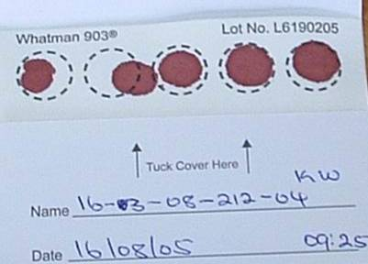

All 5 circles filled. At least 3 are valid.

**Fig2. Invalid DBS card**

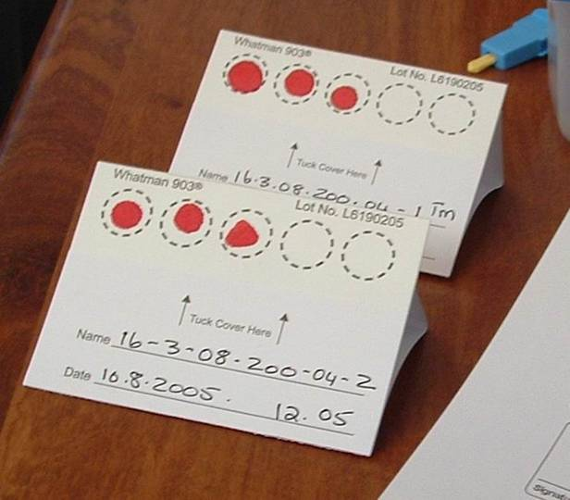

Blood spots are too small

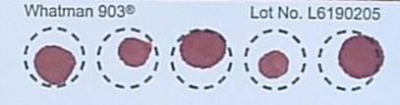

**4** Circles not filled

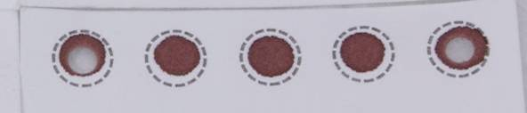

4.2**.** Blood has clotted

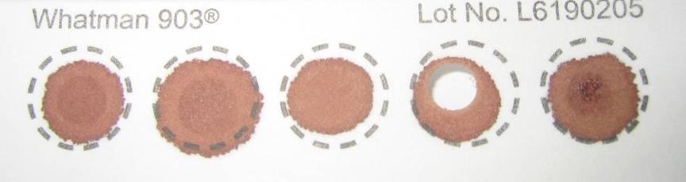

Specimen has clotted and appears layered

1. If the blood stops flowing before sufficient blood has been collected, gently massage the hand to encourage blood droplets formation. **DO NOT MILK THE FINGER** (i.e. do not squeeze or massage the finger area).

If necessary, a second finger can be cleaned and punctured using a new lancet in order to obtain adequate sample. It is important that adequate sample is collected; you must saturate each circle with blood.

1. If you are unable to obtain flowing blood using finger stick despite multiple attempts, please inform a head nurse or clinician.
2. After adequate sample is collected, give the participant gauze or swab to hold pressure to the fingertip. Elevate the fingertip above the elbow. After a matter of seconds or minutes, the bleeding should stop. No strapping, plaster, or band-aid is needed.

**3a. Handling specimen after collection in the CLINIC**

This section describes the procedure for handling a collected DBS specimen in the clinic.

1. After completing the sample collection, place the DBS card on the drying rack (Fig 3). The drying rack should ideally be placed so that the DBS cards dry in the horizontal position.
2. If no drying rack is available, the DBS card can be laid flat on a clean paper towel.
3. Fill out the lab requisition form and leave it close to the DBS card, so it can accompany the card to the lab, once dry.

**Fig 3. DBS on drying rack**

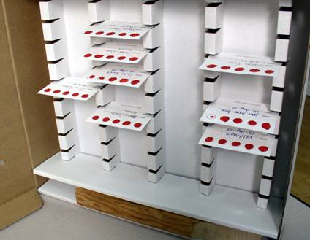

PRECAUTIONS WHEN DRYING THE DBS CARDS:

* Do not touch or smear the blood spots
* Keep away from direct sun-light, dust, and insects
* Do not heat, stack or allow DBS to touch anything during the drying process (including other DBS cards)

1. DBS cards must dry for at least 4 hours (though preferably overnight) prior to being placed in plastic bags and transported to the lab. **DO NOT USE AN EXTERNAL HEAT SOURCE TO DRY DBS.**
2. When dry, the spots will appear a uniform dark brown. The appearance should be similar to that of a dried bloodstain and no areas of red coloration should be seen.

**3b. Handling specimen after collection in the FIELD (outside of clinic) using a transport box**

This section describes the procedure for handling a collected DBS specimen in the field (outside of clinic).

1. Follow the procedure above for collecting DBS (2.1-2.16).

1. Allow the DBS card to dry sufficiently so blood is not flowing when placed in a transport box
2. Appropriately place the DBS card horizontally in a rack already provided in the transport box
3. The transport box must be carried horizontally at all times. **PROTECT YOUR DBS CARD FROM ANY DUST OR DIRECT SUNLIGHT AT ALL TIMES.**

1. When you return to the facility at the end of your tracing activities, ensure that each DBS card has had a lab requisition form filled out
2. When you arrive at the facility, remove the DBS card and leave to air dry effectively for 4 hours or till the next morning. If no drying rack is available at the facility, the DBS card can be laid flat on a clean paper towel.

1. Fill out the lab requisition form and leave it close to the DBS card, so it can accompany the card to the lab, once dry. Ensure the first two copies of the lab requisition accompany the DBS card to the lab. Retain the third copy for facility records.

**4. Packaging of DBS**

Packaging of the DBS is very important. DBS cannot be kept and/or transported at ambient temperature for longer than 14 days. If VL testing cannot be performed within 14 days from the date of collection, DBS should be transported to a central facility where there is a constant electricity supply and a -70°C freeze.

The manner in which the DBS are packaged may determine the quality of the results in the future.

1. Once the DBS card is **COMPLETELY DRY**, place the card in a gas-impermeable zip-locked plastic bag with 1 desiccant pack.
2. Humidity causes damage to the HIV virus particles and should be avoided through use of desiccant and humidity cards.
3. The patient information should be visible through the bag. Make sure the humidity card is placed in the rear of the card facing out so that we can read the card and so that it does not obscure the view of the participant information on the card.
4. We want to keep the DBS card sealed in its bag from now to when we are ready to test it. Gently apply pressure to the partially sealed bag to excel the air before sealing completely.
5. Bring the plastic bag containing the DBS along with the lab requisition form to the appropriate area in the clinic so that it can be transported to the reference laboratory. **DO NOT STAPLE THE REQUISITION FORM TO THE PLASTIC BAG** as this will puncture the bag and allow air to enter.
6. Insert DBS bag into envelope. Place lab requisitions and specimen delivery checklist into envelope. Seal envelope. Label envelope clearly (“START DBS specimens”). Send to testing lab.

_______________________________________________________________________

**PROCEDURES FOR NEEDLE STICK INJURY**

Purpose

The purpose of this section is to define procedures to follow when any Community ART staff member suffers a needle stick injury or blood contamination. This procedure applies to all staff involved in collection of blood specimens from Community ART participants.

Responsibilities

The staff members delegated to collect DBS specimens for the studyare responsible for understanding and following this section of the SOP.

The START staff supervisor is responsible for ensuring that START staff knows what action to take when one has a needle stick injury or is exposed to contaminated body fluids when handling and discarding used lancets, broken specimen containers or hazardous waste. In the event of a needle stick injury, the supervisor is responsible for ensuring that the employee receives all necessary medical attention.

Appendices

Standard Operating Procedure: Management of Occupational Exposures to potentially Infectious Substances

**Procedures**

Study staff are to follow the laid down steps in case of needle stick injury and skin exposure while working with a patient with known HIV infection.

1. Immediately wash the site with soap and running water. Antiseptics such as alcohol or chlorohexidine can be used on small wounds and puncture sites – these agents have some virucidal activity. DO NOT USE BLEACH or other caustic agents to clean the exposure site or squeeze the wound.
2. In case of mucosal exposure, the exposed surface should be flushed with numerous amount of saline or water.
3. In case of exposure to the eye, immediately flush with copious amounts of clean water
4. Contact on site or nearby In-Charge/Supervisor. If the In-Charge/Supervisor is not immediately reachable, attempts should be made to reach a head nurse based at the district.
5. The individual with potential HIV exposure should present her/himself nearby health facility for immediate HIV counseling and testing. These results should be made available to health providers during discussions about post-exposure prophylaxis (see below). Should the HIV result be negative, the staff member should follow-up with a repeat test after 3 months.

The individual with potential HIV exposure will be referred to a member of the medical team, who will provide management for post-exposure prophylaxis (see Appendix).

**15.0 Dried Blood Spot (DBS) Viral Load Log Book**

**Dried Blood Spot (DBS) Viral Load Log Book**

**Clinic Name:** _______________________________________________________

|  |  |  |  |  |
| --- | --- | --- | --- | --- |
| **Date of Specimen Collection**  **(DD/MM/YY)** | **Time of Specimen Collection**  **(HH:MM)** | **ART ID** | **Patient First Name** | **Patient Surname** |
|  |  |  |  |  |
|  |  |  |  |  |
|  |  |  |  |  |
|  |  |  |  |  |
|  |  |  |  |  |
|  |  |  |  |  |
|  |  |  |  |  |
|  |  |  |  |  |
|  |  |  |  |  |
|  |  |  |  |  |
|  |  |  |  |  |
|  |  |  |  |  |
|  |  |  |  |  |
|  |  |  |  |  |
|  |  |  |  |  |
|  |  |  |  |  |